**Wordnet Service Report**

**Introduction:**

WordNet® is a large lexical database of English. Nouns, verbs, adjectives and adverbs are grouped into sets of cognitive synonyms (synsets), each expressing a distinct concept. Synsets are interlinked by means of conceptual-semantic and lexical relations. The resulting network of meaningfully related words and concepts can be navigated with the [browser(link is external)](http://wordnetweb.princeton.edu/perl/webwn). WordNet is also freely and publicly available for [download](https://wordnet.princeton.edu/download). WordNet's structure makes it a useful tool for computational linguistics and natural language processing.

WordNet superficially resembles a thesaurus, in that it groups words together based on their meanings. However, there are some important distinctions. First, WordNet interlinks not just word forms—strings of letters—but specific senses of words. As a result, words that are found in close proximity to one another in the network are semantically disambiguated. Second, WordNet labels the semantic relations among words, whereas the groupings of words in a thesaurus does not follow any explicit pattern other than meaning similarity.

We will be using wordnet database to lookup the searched word in the database, if there is any match then we will extract the relevant data and sends it back to client interface to render it for the user to see the results.

**UML Diagram:**

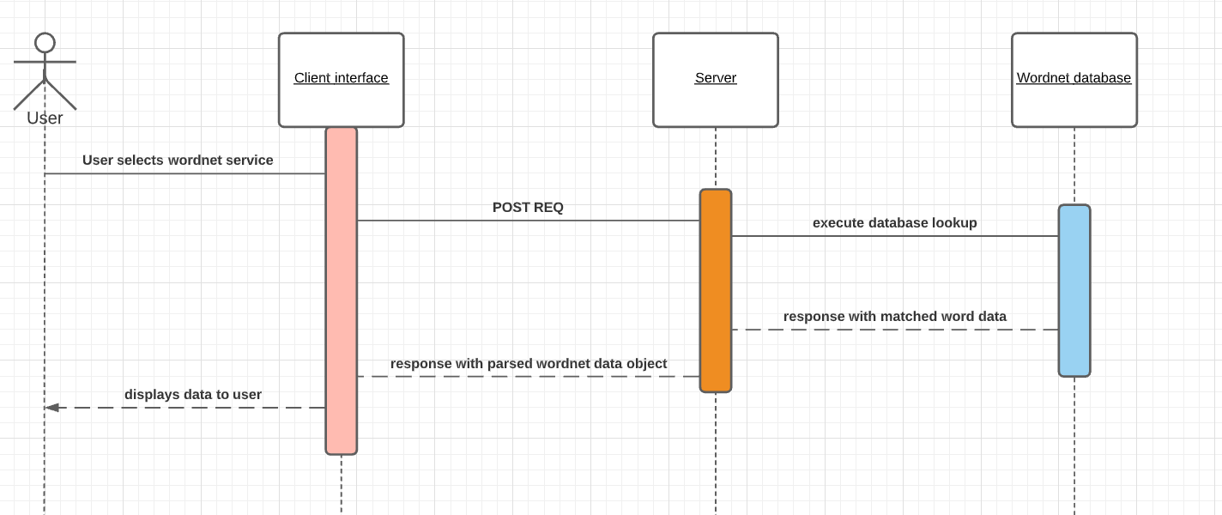

The above diagram represents the sequence diagram of the complete user-server-API interaction. The sequence diagram shows how the data is fetched from the API and parsed and sent back to the client interface which displays this data to the user in a format.

**Evaluation:**

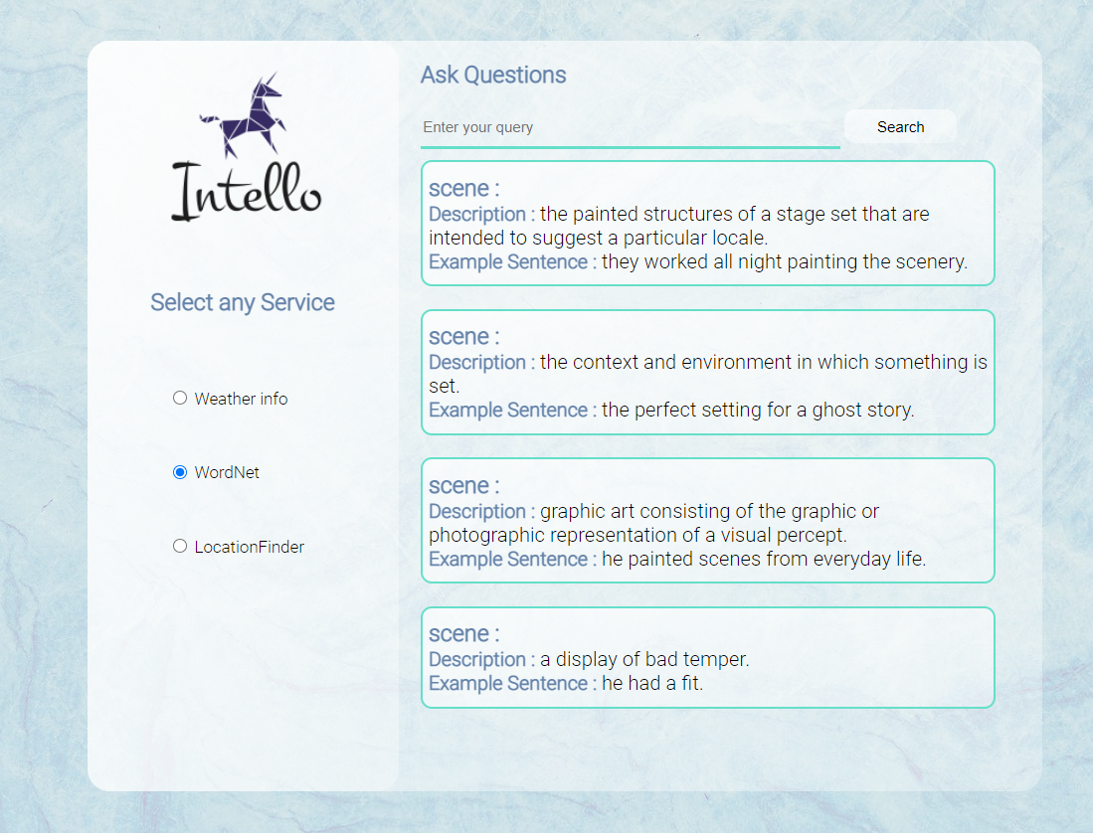

The above diagram shows the format in which the data will be represented to the user. As one word can have multiple meaning , I am only going to fetch first 4 meaning if exist and display them with searched word , its description and example if any.it is done to maintain simplicity.

Integrating this functionality was also a great learning experience as I learned how to represents the data to the user and how much.

I used ejs template to render the data of different word using a single page rather than having separate page for each word.

**Client and Server Interaction:**

When the user selects the wordnet service and enters the word and hit search, client interface makes an post request to the server and server search for the match of the word in the wordnet database and if there is match it will return the data object as a response. The server then parse the data and collect the required data from the response and then render the page with this data as a response to client post request. This data is now visible to the user in the client interface.

**References:**

<https://wordnet.princeton.edu/>